Population Structure:

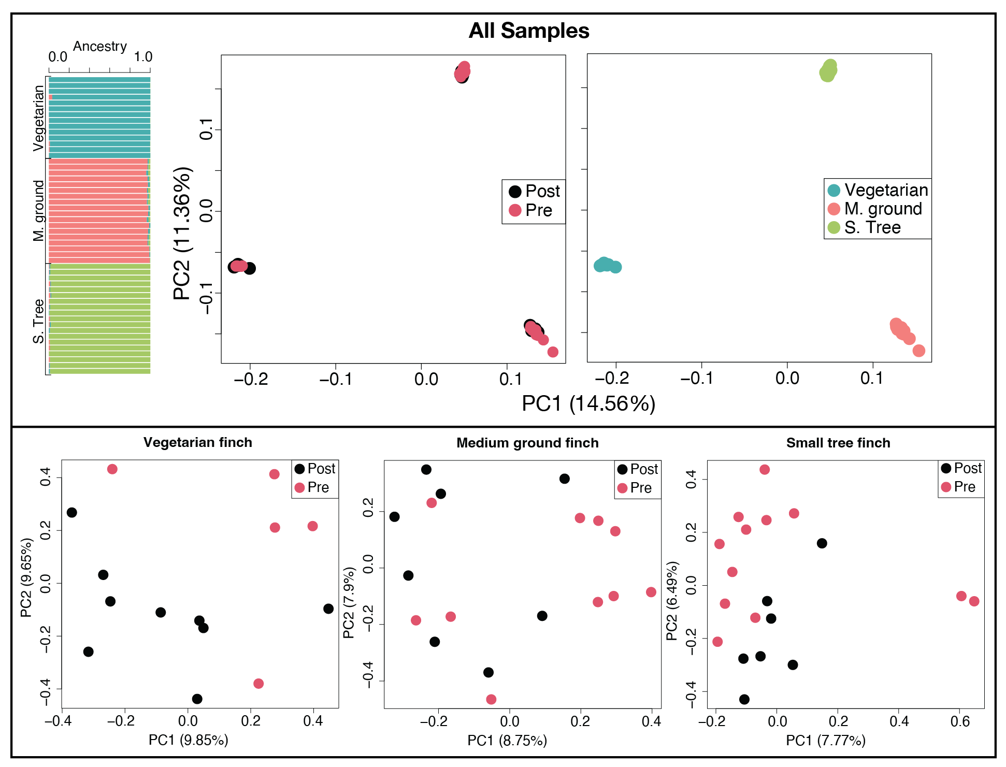

|  |  |  |  |  |  |
| --- | --- | --- | --- | --- | --- |
| Species | FST | ∆Tajima | Max FST | Min ∆Tajima | Max ∆Tajima |
| Vegetarian finch | 0.038 | 0.338 | 0.369 | -3.644 | 4.536 |
| M. ground finch | 0.031 | -0.176 | 0.338 | -4.193 | 3.719 |
| S. tree finch | 0.029 | -0.173 | 0.299 | -3.912 | 3.859 |

|  |  |  |  |  |
| --- | --- | --- | --- | --- |
| Species | Treatment | Tajima’s D | Watterson’s Theta | pi (tP) |
| Vegetarian finch | Pre | 0.678 | 0.093 | 0.105 |
|  | Post | 1.016 | 0.085 | 0.104 |
| M. ground finch | Pre | 1.062 | 0.195 | 0.245 |
|  | Post | 0.886 | 0.205 | 0.247 |
| S. tree finch | Pre | 0.512 | 0.158 | 0.180 |
|  | Post | 0.340 | 0.166 | 0.180 |

**Selection Analyses**

**Composite Statistic – validation plots**

Vegetarian finch



Medium ground finch



Small tree finch



**Manhattan plots**

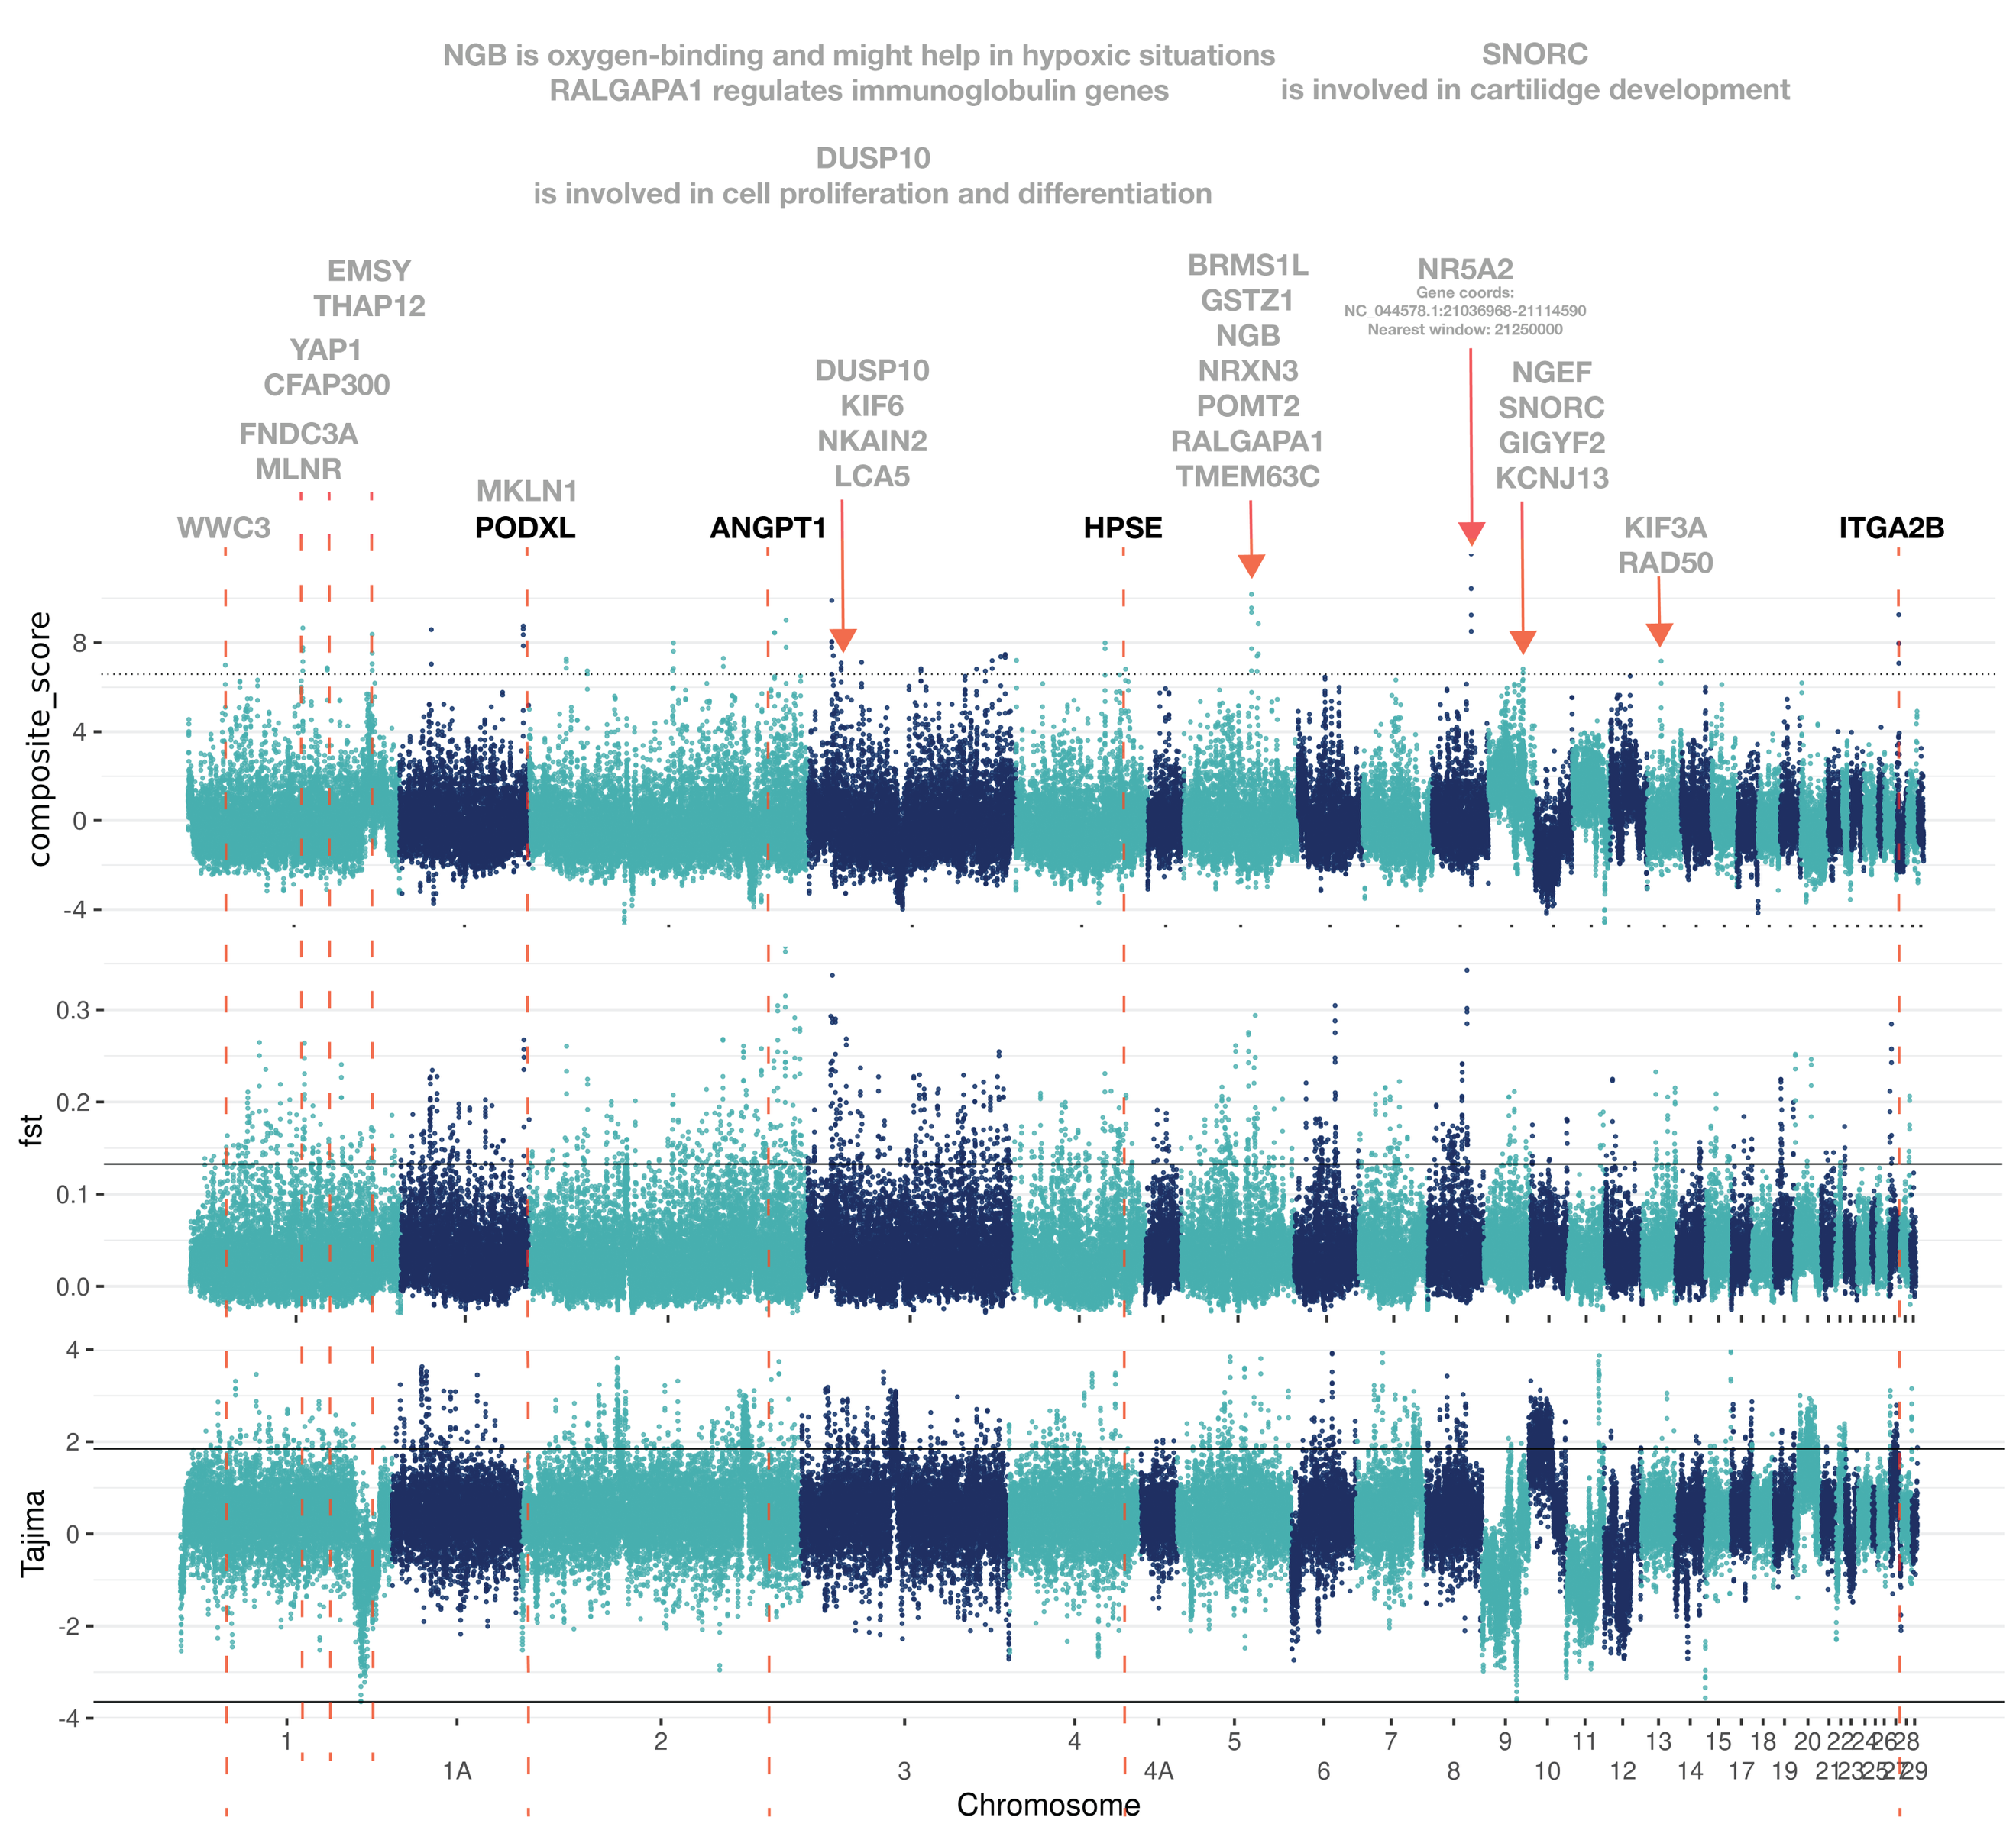

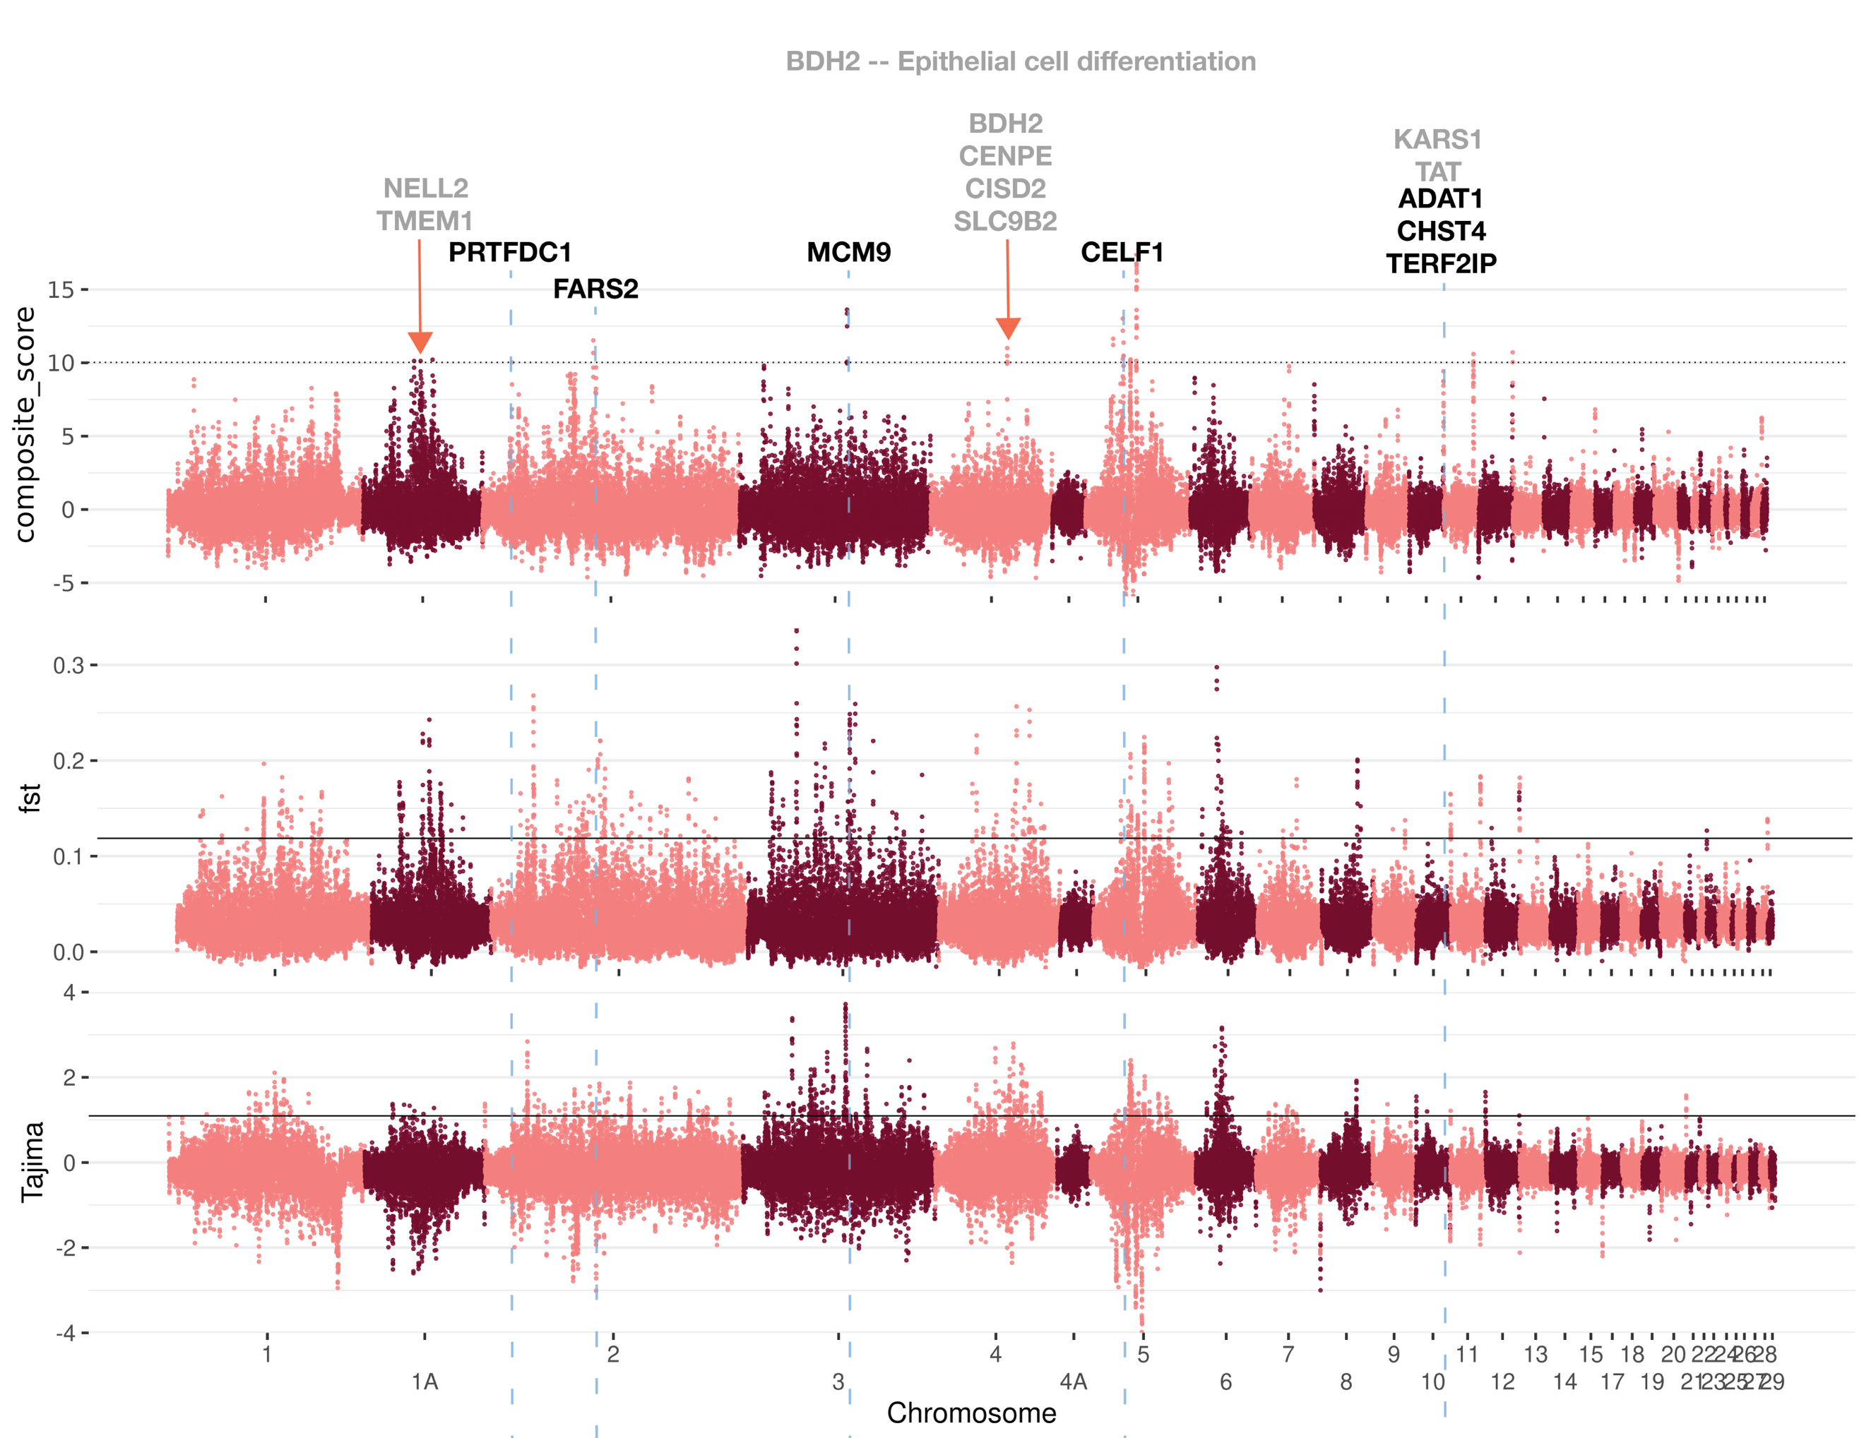

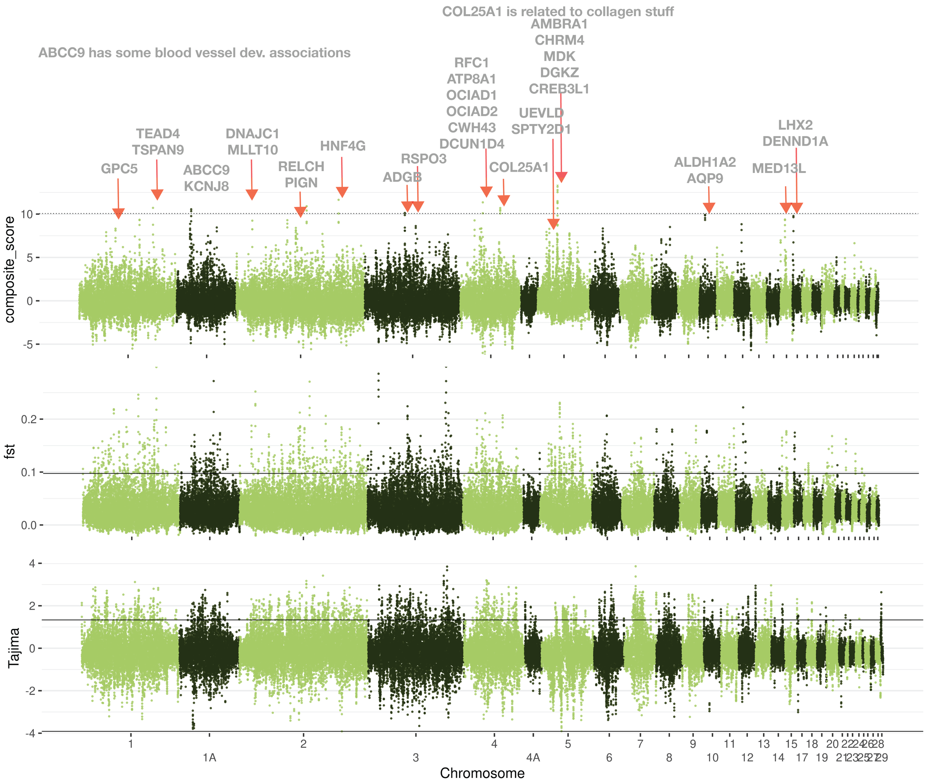

**RAiSD Results**

Vegetarian finch GO terms:

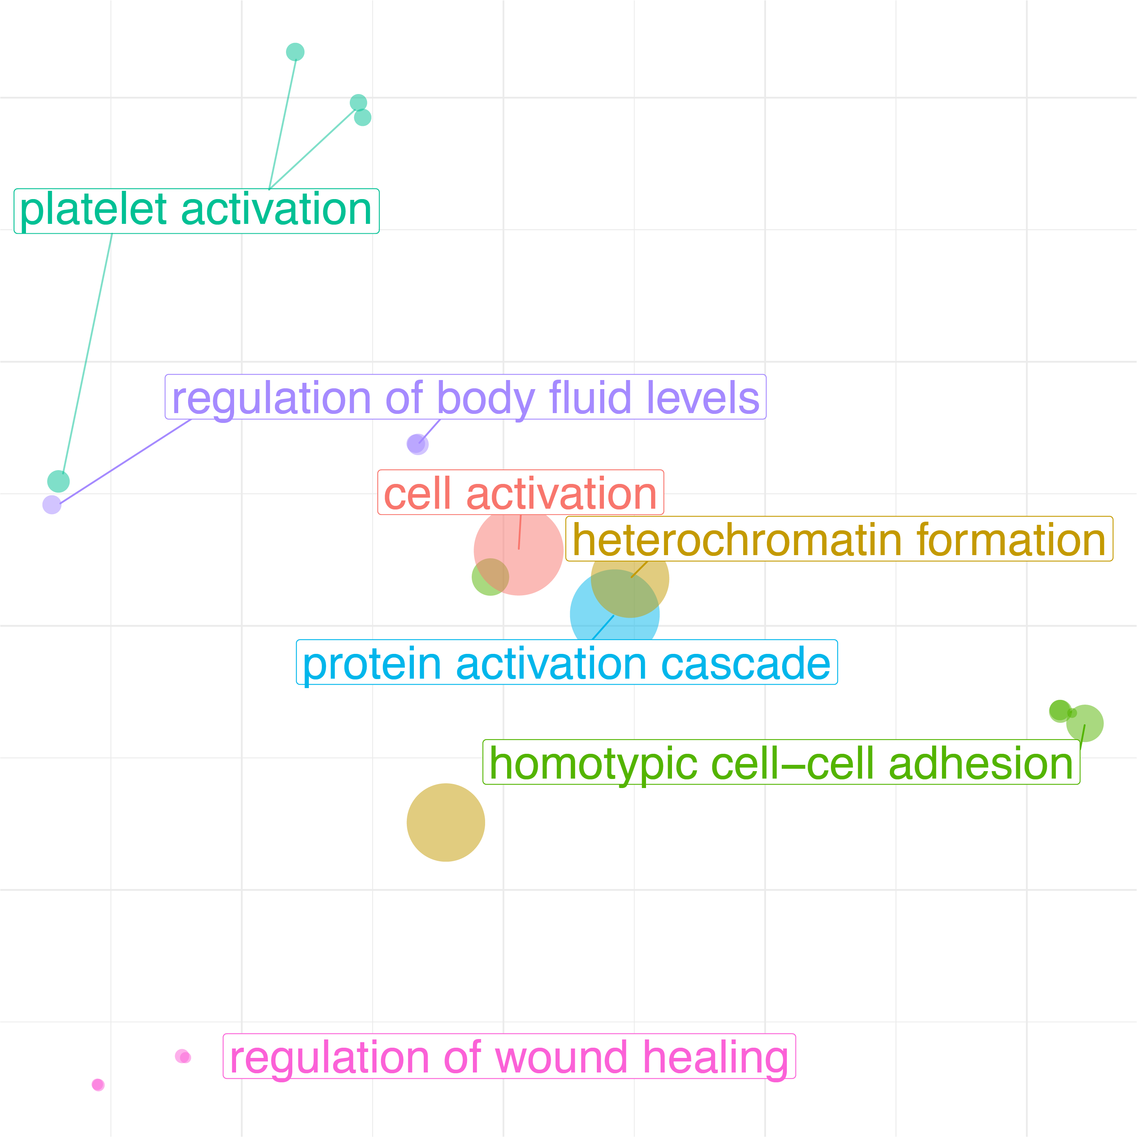

**GO terms:**

|  |  |  |  |
| --- | --- | --- | --- |
| **Species** | **PANTHER GO-Slim Biological Process** | **GO Term** | **q-value** |
| Vegetarian finch | Platelet aggregation | GO:0070527 | <0.001 |
|  | Platelet activation | GO:0030168 | <0.001 |
|  | Cell activation | GO:0001775 | <0.001 |
|  | Blood coagulation | GO:0007596 | <0.001 |
|  | Hemostasis | GO:0007599 | <0.001 |
|  | Regulation of body fluid levels | GO:0050878 | 0.002 |
|  | Wound healing | GO:0042060 | 0.007 |
|  | Response to wounding | GO:0009611 | 0.002 |
|  | Coagulation | GO:0050817 | <0.001 |
|  | Homotypic cell-cell adhesion | GO:0034109 | <0.001 |
|  | Protein activation cascade | GO:0072376 | <0.001 |
|  | Negative regulation of blood coagulation | GO:0030195 | 0.002 |
|  | Regulation of wound healing | GO:0061041 | 0.005 |
|  | Regulation of response to wounding | GO:1903034 | 0.005 |
|  | Negative regulation of coagulation | GO:0050819 | 0.003 |
|  | Regulation of coagulation | GO:0050818 | 0.007 |
|  | Positive regulation of cell-cell adhesion | GO:0022409 | 0.017 |
| Medium ground finch | None | NA | NA |
| Small tree finch | None | NA | NA |

**Genes involved:**

|  |  |  |
| --- | --- | --- |
| Gene | Name | Function |
| FGA | Fibrinogen alpha chain | Fibrinogen is a precursor to fibrin, major component of blood clots |
| FGB | Fibrinogen beta chain | Fibrinogen is a precursor to fibrin, major component of blood clots |
| HELLS | Helicase, lymphoid specific | Cellular proliferation |
| FGFR1OP2 | FGFR1 oncogene partner 2 homolog | Involved in wound healing |

**Parallel Selection**

Composite Statistic top 1%



Genes in all three lists: BMPER, NUDT4, TENM3

|  |  |  |
| --- | --- | --- |
| Gene | Name | Function |
| BMPER | BMP Binding Endothelial Regulator | Regulates bone and cartilage growth, endothelial [angiogenesis](https://pubmed-ncbi-nlm-nih-gov.ezproxy1.library.arizona.edu/18787191/) |
| NUDT4 | Nudix Hydrolase | “Regulates the turnover of diphosphoinositol polyphosphates” |
| TENM3 | Teneurin Transmembrane Protein | Visual system, cell adhesion |

*BMPER and TENM3 both seem relevant to visual system, especially retinal blood vessel development

|  |  |  |  |  |  |  |  |  |
| --- | --- | --- | --- | --- | --- | --- | --- | --- |
| Gene | Species | Site | Between exons | FST | Type | Pre-freq | Post-freq | CpG increased? |
| BMPER | CRA | 46511099 | 3,4 | 0.246 | CpG | 0.5 | 0.91666667 | TRUE |
|  | FOR | 46576940 | 12,13 | 0.402 | CpG | 0 | 0.35714286 | TRUE |
|  |  | 46602867 | 14,15 | 0.376 | CpG | 0.9375 | 0.58333333 | FALSE |
|  |  | 46580935 | 13,14 | 0.331 | CpG | 0 | 0.42857143 | TRUE |
|  |  | 46584598 | 9,10 | 0.328 | CpG | 1 | 0.71428571 | FALSE |
|  |  | 46580828 | 13,14 | 0.303 | CpG | 0.05 | 0.42857143 | TRUE |
|  | PAR | 46513495 | 3,4 | 0.258 | CpG | 1 | 0.83333333 | FALSE |
|  |  | 46578649 | 12,13 | 0.245 | CpG | 0.45 | 0.07142857 | FALSE |
| NUDT4 | CRA | 28603313 | 4,5 | 0.245 | CpG | 0.5 | 0.07142857 | FALSE |
|  | FOR | 28621591 | 1,2 | 0.206 | CpG | 0.27777778 | 0 | FALSE |
|  | PAR | 28601647 | 5`UTR | 0.319 | CpG | 0.40909091 | 0 | FALSE |
|  |  | 28614781 | 1,2 | 0.25 | CpG | 0.33333333 | 0 | FALSE |
|  |  | 28601802 | 5`UTR | 0.247 | not CpG |  |  | FALSE |
|  |  | 28600154 | 5`UTR | 0.241 | CpG | 0.41666667 | 0.07142857 | FALSE |
| TENM3 | CRA | 33849547 | 4,5 | 0.656 | CpG | 0.3 | 1 | TRUE |
|  | FOR | 33653784 | 6,7 | 0.429 | CpG | 0.9375 | 0.41666667 | FALSE |
|  |  | 33652266 | 6,7 | 0.417 | CpG | 0 | 0.42857143 | TRUE |
|  |  | 34069815 | 3,4 | 0.412 | CpG | 0.21428571 | 0.6875 | TRUE |
|  |  | 33149057 | 12,13 | 0.348 | CpG | 1 | 0.58333333 | FALSE |
|  | PAR | 34225827 | 1,2 | 0.486 | CpG | 1 | 0.57142857 | FALSE |
|  |  | 34235390 | 1,2 | 0.408 | CpG | 1 | 0.64285714 | FALSE |
|  |  | 34248653 | 1,2 | 0.364 | CpG | 0.875 | 0.42857143 | FALSE |

Windowed analyses of composite statistics

Significant GO terms from the composite statistical analysis using a window cutoff of 0.1% and a q-value cutoff of 0.05.

Genes for *Platyspiza crassirostris*: PODXL, HPSE, ANGPT1, ITGA2B.

Genes for *Geospia fortis*: CHST4, CELF1, TERF2IP, PRTFDC1, ADAT1, FARS2, MCM9

|  |  |  |  |
| --- | --- | --- | --- |
| **Species** | **PANTHER GO-Slim Biological Process** | **GO Term** | **q-value** |
| Vegetarian finch | regulation of cell adhesion mediated by integrin | GO:0033628 | 0.043 |
|  | angiogenesis | GO:0001525 | 0.014 |
|  | blood vessel morphogenesis | GO:0048514 | 0.011 |
|  | blood vessel development | GO:0001568 | 0.008 |
|  | vasculature development | GO:0001944 | 0.007 |
|  | tube morphogenesis | GO:0035239 | 0.005 |
|  | tube development | GO:0035295 | 0.006 |
| Medium ground finch | tRNA metabolic process | GO:0007519 | <0.001 |
|  | nucleic acid metabolic process | GO:0060538 | <0.001 |
|  | nucleobase-containing compound metabolic process | GO:0007517 | <0.001 |
|  | heterocycle metabolic process | GO:0060537 | <0.001 |
|  | cellular aromatic compound metabolic process | GO:0010720 | <0.001 |
| Small tree finch | None | None | NA |
| **Multispecies analyses** | | | |
| All species | hippo signaling | GO:0035329 | 0.021 |
| Pairwise overlap | None | None | NA |
| Composite all taxa | None | None | NA |

* The gene lists for the multispecies analyses are as follows: “All species” consists of genes found in any of the three species. “Pairwise overlap” consists of genes found in two or more species. “Composite all taxa” consists of genes with a high additive scaled composite score across all three taxa (I scaled and centered the composite score for each species and then added them).

**Individual Gene Analysis**

ANGPT1:

We found no high FST snps in an exon in ANGPT1. We found a cluster of high FST SNPs between exon 1 and 2 and one SNP near exon 5, but none of these were CpG sites in either the ancestral or derived genotype.

HPSE:

We identified one genotype with a high relative FST (0.327) within the transcribed region of the HPSE gene, specifically within the 3’UTR. The derived allele at this site increased from a frequency of 0.5 pre-invasion to 0.875 post-invasion. We used RBPmap to predict changes to miRNA binding motifs resulting from this mutation. We found one binding motif associated with both the derived and ancestral genotype, and two associated only with the derived genotype. In all three motifs, neither allele perfectly matched the motif sequence, but in all three circumstances, the derived genotype matched the motif and the ancestral did not.

ITGA2B:

There is a block of high FST in the region after ITGA2B

PODXL

There is a missense mutation (P295A). All pre-invasion taxa were homozygous for the mutation (6/6 chromosomes), while only 3/10 chromosomes in the post-invasion sample contained the mutation. This mutation is expected to be tolerated (SIFT, tolerance score = 0.35, median sequence conservation 4.32), but may have impacts on protein folding and structure. Additionally, we found four synonymous mutations in the coding region at sites 67,381,354, 67,381,955, 67,371,273, and 67,381,476.

**Beak and body size genes ; species diversification**

*HMGA2* 

**Average values**

|  |  |  |  |  |  |  |  |
| --- | --- | --- | --- | --- | --- | --- | --- |
|  |  | **Vegetarian** | | **Medium ground** | | **Small tree** | |
| Gene | Paper | FST | ∆Tajima | FST | ∆Tajima | FST | ∆Tajima |
| HMGA2 |  | 0.024 | -1.330 | 0.069 | ? | 0.064 | ? |
| PLAG1 |  | 0.024 | 0.528 | 0.011 |  | 0.009 |  |
| SUPT3H |  | 0.009 | 1.2209 | 0.040 |  | 0.038 |  |
| IGFBP2 |  | 0.033 | 0.409 | 0.017 |  | 0.035 |  |
|  |  |  |  |  |  |  |  |
|  |  |  |  |  |  |  |  |
|  |  |  |  |  |  |  |  |

Not in our gene list: ALX1

**Removed text:**

Using a combined list of all genes identified as outliers in any of the three taxa, we found overrepresentation of genes involved in hippo signaling (GO:0035329, q=0.021).

Two genes drove the signal of overrepresentation of genes involved in hippo signaling using the combined list of all genes identified as outliers in any of the three taxa, TEAD4 and YAP1. YAP1 encodes the protein Yes1 Associated Transcriptional Regulator and TEAD4 encodes TEA Domain Transcription Factor 4. Both regulate the integrity of endothelial tissue and play a role in tissue regeneration (*14*) YAP1 was only identified in the top 0.1% of outliers in the vegetarian finch while TEAD4 was only identified in the small tree finch. In YAP1, we found two SNPs between exon 2 and 3 with a high FST (0. 299 and 0.300) with an ancestral 5`-CA-3` genotype and a derived 5`-CG-3` genotype, permitting gene expression regulation via CpG methylation in the derived but not the ancestral genotypes. Frequency of the derived type declined following invasion of the vampire fly, indicating selection against regulation of YAP1 through these sites.

RAiSD results

Timesweeper results

Parallel Selection results

Evidence of parallel selection

|  |  |  |  |
| --- | --- | --- | --- |
| **Analysis** | **Species Pair** | **Result (p-value)** | **FDR (q-value)** |
| FST (1% cutoff) | CRA x FOR |  |  |
|  | CRA x PAR |  |  |
|  | FOR x PAR |  |  |
| FST (0.1% cutoff) | CRA x FOR |  |  |
|  | CRA x PAR |  |  |
|  | FOR x PAR |  |  |
| ∆Tajima (1% cutoff) | CRA x FOR |  |  |
|  | CRA x PAR |  |  |
|  | FOR x PAR |  |  |
| ∆Tajima (0.1% cutoff) | CRA x FOR |  |  |
|  | CRA x PAR |  |  |
|  | FOR x PAR |  |  |
| ∆AF (1% cutoff) | CRA x FOR |  |  |
|  | CRA x PAR |  |  |
|  | FOR x PAR |  |  |
| ∆AF (0.1% cutoff) | CRA x FOR |  |  |
|  | CRA x PAR |  |  |
|  | FOR x PAR |  |  |
| Composite (1% cutoff) | CRA x FOR | 0.217 |  |
|  | **CRA x PAR** | **0.016** |  |
|  | **FOR x PAR** | **<0.001** |  |
| Composite (0.1% cutoff) | CRA x FOR | NA |  |
|  | CRA x PAR | NA |  |
|  | FOR x PAR | NA |  |

Relaxed selection results

**Figures**